1. **JAVASCRIPT BASIC & DOM**
2. **What is JavaScript?**

JavaScript is an object-based scripting language which is lightweight and cross-platform.

It is an interpreted, fully-fledged programming language that enables dynamic interactivity on websites when applied to an HTML document.

It was introduced in the year of 1995 for adding programs to the webpages in the Netscape Navigator browser.

1. **Which company developed Javascript?**

Javascript was invented by Brendan Eich in 1995. It was developed for Netscape 2, and became the ECMA-262 standard in 1997.

1. **What are uncleared and undefined variables?**

**Uncleared**: it occurs when a variable which hasn’t been declared using var, let or const is being tried to access.

**Undefined**: it occurs when a variable has been declard using var,let and const but isn’t given value.

1. **Write the code for adding new elements dynamically?**

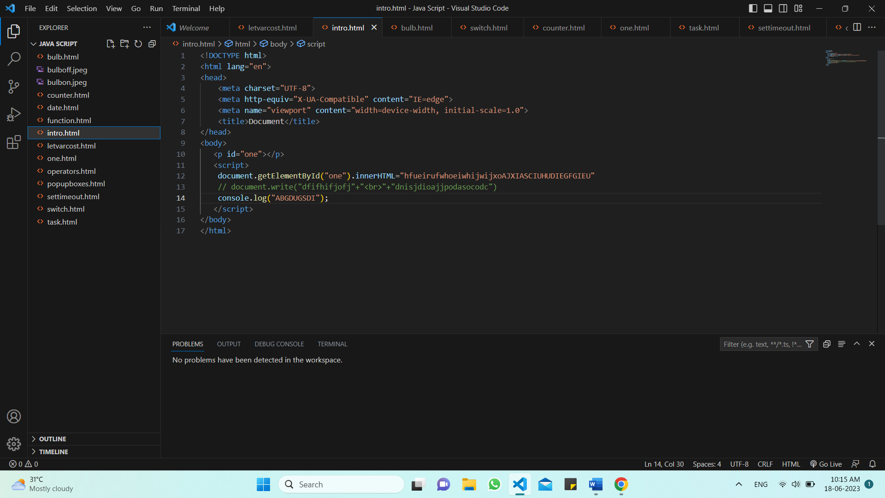

1. **What is the difference between ViewState and SessionState?**

The basic difference between these two is that the Viewstate is to manage state at the client’s end, making state management easy for end-user while Sessionstate manages state at the server’s end, making it easy to manage content from this end too.

**Viewstate:** only page level maintenance.

Only one page, not several pages, can display the viewstate**.**

When a new page is loaded, Viewstate values are lost or cleared.

**Sessionstate**: cleared by the programmer

Cleared by the user

Cleared when Timeout occurs.

1. **What is === operator?**

It is called equality. It is checks whether its two operands are equal, returning a result. unlike equality operator, the strict equality operator always considers operands of different types to be different.

If the operands are of difference types, return false.

If both operands are objects, return true only if they refer to the same object.

If both operands are null or both operands are undefined , return true.

1. **How can the style/class of an element be changed?**

The “className” attribute can be used to change the class of the element.

Style.property

Changing the class itself.

1. **How to read and write a file using JavaScript?**

The file is read using the fs.readFile() function, which is an inbuilt method.

This technique reads the full file into memory ans stores it in a buffer.

Fs.readFile(file_name,encoding,callback_function)

The fs.writeFile() function is used to write data to a file in an asynchronous manner. If the file already exists, it aill be replaced.

Fs.writeFile(file_name, data, options, callback)

1. **What are all the looping structures in JavaScript?**

The js loops are used to iterate the piece of code using for,while,do while or for-in loops. It makes the code compact.

There are five types of loops in javascript:

For loop

While loop

Do-while loop

For-in loop

For-of loop

1. **How can you convert the string of any base to an integer in JavaScript?**

To convert a string to an integer parselnt(), number(), and unary operator(+) function is used in JavaScript.

1. **What is the function of the delete operator?**

The delete operator in js is used to delete an object’s property.

If it is used to delete an object property that already exists, it returns true and removes the property from the object.

The only time false will be returned is when the delete operator is used to delete a variable or a function.

1. **What are the all types of popup boxes available in Javascript?**

**There are three types of popup boxes in js**

1. **Alert**

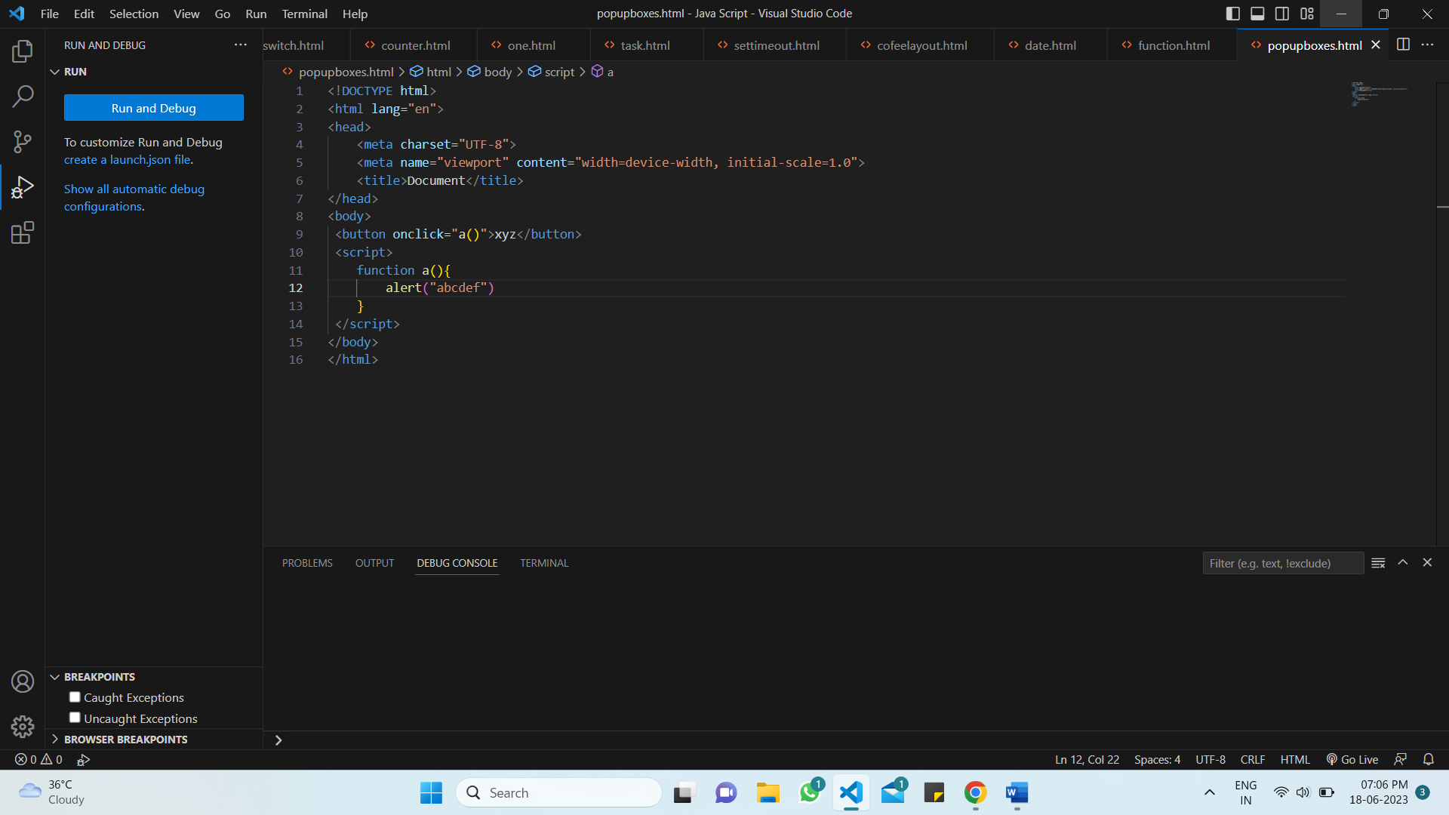

1. **Confirm**

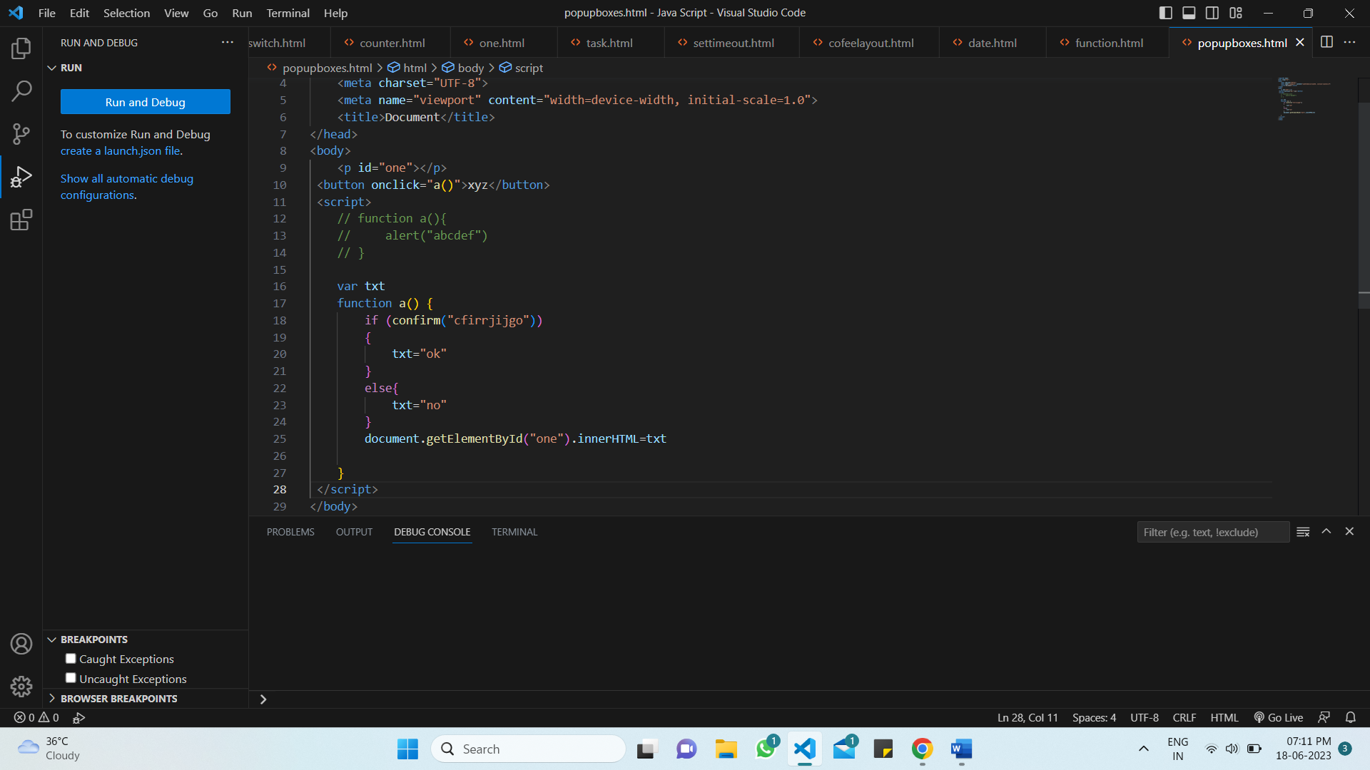

1. Prompt

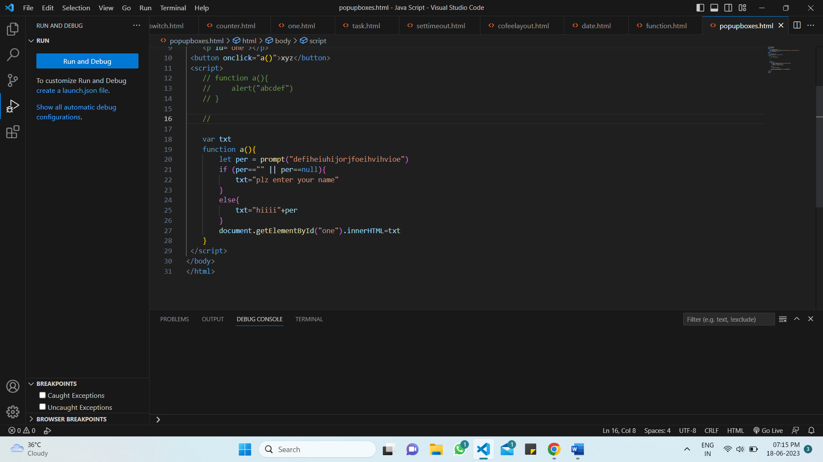

**(13)**  **what is the use of void (0)?**

It is used to prevent any side effects caused while inserting an expression in a webpage.

When you use Javascript void 0, it will return an undefined primitive value. This will prevent the browser from opening a new or reloading the web page and allowing to call the Javascript.

**(14) How can page be forced to load another page in JavaScript?**

We can use window.location object to force a page to load another page. We can use the location object to see the URL of a new page.

**(15)** **what are the disadvantages of using innerHTML in JavaScript?**

InnerHTML is slow

Event handlers attached to any DOM element are preserved.

Replacement is done everywhere.

It is not possible to append innerHTML.

Breakes the document

Used for cross-site scripting.

**(16) what is the use of NaN FUNCTION?**

IT is a shoert form of “ not- a- number”.

Nan is a number that is not a legal number.

The number .isNaN() method returns true if the value is NaN, and type is a number.